

PHYSICAL EDUCATION STUDIES

**ATAR 11 FUNCTIONAL ANATOMY TEST**

**2019**

**Question/Answer Booklet**

Name: ____________________________________

***Time allowed for this paper***

Reading/planning time before commencing work: Five minutes

Working time for paper: Fifty minutes

|  |  |
| --- | --- |
| ***Material required/recommended for this paper***  **To be provided by the supervisor**  This Question/Answer booklet  Sections One, Two and Three: Write your answers in this Question/Answer booklet.  Spare lined paper  **To be provided by the candidate**  Standard items:Pens, pencil, eraser, correction fluid, highlighter, ruler, |  |

Special items: **non programmable calculator**

***Important note to candidates***

No other items may be taken into the examination room. It is **your** responsibility to ensure that you do not have any unauthorised notes or other items of a non-personal nature in the examination room. If you have any unauthorised material with you, hand it to the supervisor **before** reading any further.

***Structure of this paper***

|  |  |  |  |  |
| --- | --- | --- | --- | --- |
| Section | Number of questions available | Number of questions to be attempted | Suggested working time  (minutes) | Marks available |
| Section One:  Multiple-Choice | 10 | 10 | 10 | 10 |
| Section Two:  Short Answer | 5 | 5 | 15 | 19 |
| Section Three:  Extended Answer | 2 | 2 | 30 | 20 |
|  |  |  | Total Marks | 49 |

**Instructions to candidates**

1. The rules for the conduct of this exam have been outlined. Sitting this examination implies that you agree to abide by these rules.

2. Answer all questions according to the following instructions.

Section One: Answer **all** questions on the separate Multiple-choice Answer Sheet provided. For each question shade the box to indicate your answer. Use only a blue or black pen to shade the boxes. If you make a mistake, place a cross through that square, do not erase or use correction fluid, and shade your new answer. Marks will not be deducted for incorrect answers. No mark will be given if more than one answer is completed for any reason.

Section Two and Three: Write answers to in this Question/Answer Booklet.

3. You must be careful to confine your responses to the specific questions asked and to follow any instructions that are specific to a particular question.

4. Spare pages are included at the end of this booklet. They can be used for planning your responses and/or as additional space if required to continue an answer.

* Planning: If you use the spare pages for planning, indicate this clearly at the top of the page.
* Continuing an answer: if you need to use the space to continue an answer, indicate in the original answer space where the answer is continued, i.e. give the page number. Fill in the number of the question(s) that you are continuing to answer at the top of the page

**Section One – Multiple Choice (10 marks)**

This section has **10** questions. Answer **all** questions. For each question circle the box to indicate your answer. Use only a blue or black pen to circle the letters. If you make a mistake, place a cross through that letter, do not erase or use correction fluid, and circle your new answer. Marks will not be deducted for incorrect answers. No marks will be given if more than one answer is completed for any reason.

Suggested working time: 10 minutes.

1. The bones that form the wrist are the:
   1. Metacarpals
   2. Carpals
   3. Tarsals
   4. Phalanges
2. Skeletal muscles:
   1. Push and pull on bones to create movement
   2. Pull on bones to create movement
   3. Give the body some of its shape
   4. Pump blood around the body
3. Pronation is described as:
   1. The joint angle being decreased
   2. Tilting the sole of the foot inwards
   3. Moving the hands into a palm down position
   4. Moving the hands into a palm up position
4. An example of an eccentric contraction is:
   1. Running down a hill
   2. A bicep curl
   3. Holding a static position
   4. One that requires specialized equipment
5. Slow twitch muscle fibres are:
   1. Red in colour and produce relative low forces Lactate sports
   2. Red in colour and fatigue quickly Power sports
   3. White in colour and fatigue quickly
   4. White in colour and contract rapidly
6. Which of the following correctly identifies the structure of the respiratory system?

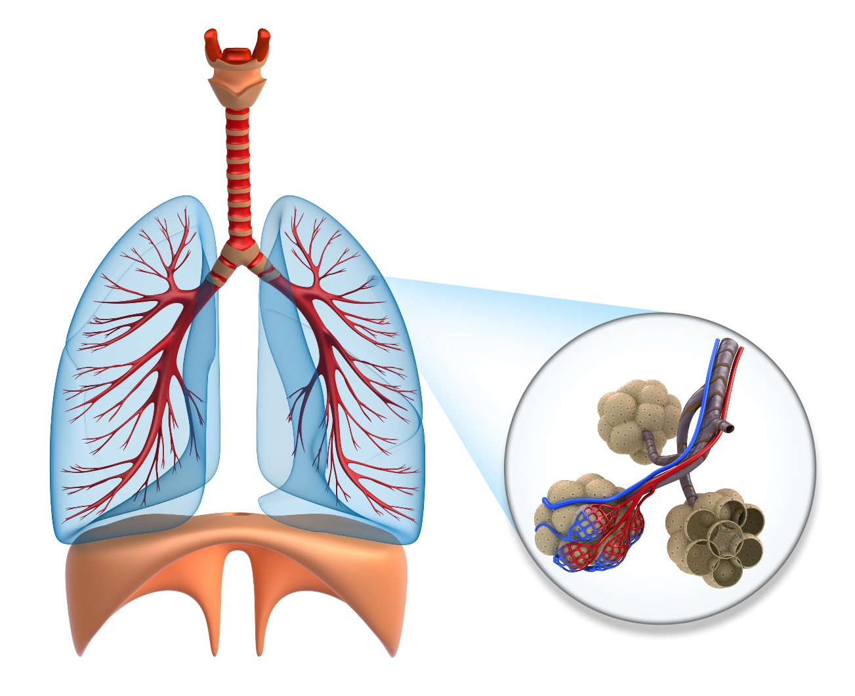

A

B

E

C

D

1. A: bronchii B: bronchioles C: alveoli D: trachea E: diaphragm
2. A: bronchioles B: bronchii C: alveoli D: diaphragm E: trachea
3. A: alveoli B: bronchii C: bronchioles D: diaphragm E: trachea
4. A: bronchii B: bronchioles C: alveoli D: diaphragm E: trachea
5. Which of the following best describes the differences between arteries and veins?
   1. Arteries carry blood away from the heart and have thin walls. Veins carry blood towards the heart and thick walls
   2. Arteries carry blood away from the heart and have thick, elastic walls. Veins carry blood towards the heart and contain valves
   3. Arteries carry blood towards the heart and have thick, elastic walls. Veins carry blood away from the heart and contain valves
   4. Arteries carry oxygenated blood and veins carry deoxygenated blood
6. The respiratory system plays a vital role in delivering oxygen from the atmosphere to the lungs. An oxygen molecule will travel from the atmosphere, through the body, as follows:
7. Mouth/nose, larynx, pharynx, trachea, bronchus, bronchioles, alveoli
8. Mouth/nose, pharynx, larynx, trachea, bronchioles, bronchus, alveoli
9. Mouth/nose, larynx, trachea, pharynx, alveoli, bronchus, bronchioles
10. Mouth/nose, pharynx, larynx, trachea, bronchus, bronchioles, alveoli
11. Muscles work in pairs to enable movement at a particular joint. Choose which one of the following correctly describes the action of the muscles when a player extends at the knee while kicking a ball. The:
12. Gluteus maximus contracts and quadriceps lengthens
13. Quadriceps contract and the hamstrings lengthens
14. Hamstrings contract and quadriceps lengthens
15. Quadriceps contract and gluteus maximus lengthens

**END OF SECTION ONE**

**Section Two: Short answer (20 MARKS)**

This section has **six (6)** questions. Answer **all** questions. Write your answers in the spaces provided in this Question/Answer Booklet. Wherever possible, confine your answers to the line spaces provided. Use a blue or black pen (**not** pencil) for this section.

Spare pages are included at the end of this booklet. They can be used for planning your responses and/or as additional space if required to continue an answer.

* Planning: If you use the spare pages for planning, indicate this clearly at the top of the page.
* Continuing an answer: if you need to use the space to continue an answer, indicate in the original answer space where the answer is continued, i.e. give the page number. Fill in the number of the question(s) that you are continuing to answer at the top of the page.

Suggested working time: 15 minutes.

1. Complete the table by identifying the joint involved, antagonist pairs, and movement of the joint.

(3 marks)

|  |  |  |  |
| --- | --- | --- | --- |
| Action | Antagonist pairs | Joint involved | Movement |
| Catching a football |  |  |  |

1. Explain what is meant by contractibility, extendibility, elasticity and excitability.

(4 marks)

_____________________________________________________________________________________________________________________________________________________________________________________________________________________________________________________________________________________________________________________________________________________________________________________________________________________________________________________________________________________

1. Label the following diagram.

(5 marks)

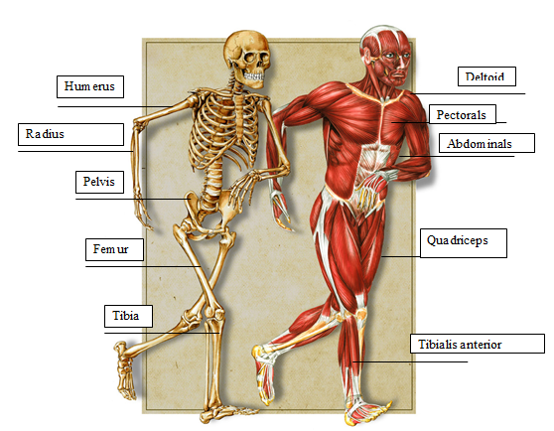

1. There are two main types of muscle fibres, fast-twitch fibres and slow-twitch fibres. The percentage of fast-twitch fibres compared to slow-twitch fibres that an athlete has depends of the characteristics of the individual and their training. Give **one** example of a type of athlete you would expect to have a significantly higher percentage of fast twitch fibres and **one** example of a type of athlete you would expect to have a significantly higher percentage of slow twitch fibres.

(2 marks)

____________________________________________________________________________________________________________________________________________________________________________________________________________________________________________________________________________

1. The image below is a representation of a blood vessel showing the three main components of blood. Use the diagram to complete the table.

(5 marks)

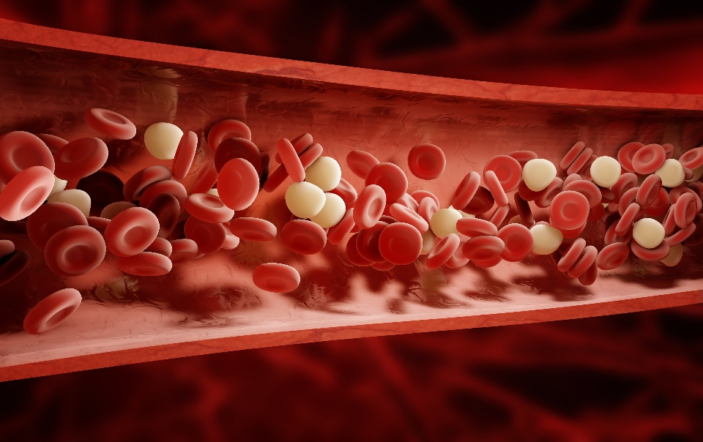

**A**

**B**

**C**

|  |  |  |
| --- | --- | --- |
| Structure | Name | Function |
| A | **Pl**  **P** | Liquid component of the blood in which the other cells are suspended. |
| B |  |  |
| C |  |  |

**END OF SECTION TWO**

**Section Three: Extended answer (20 MARKS)**

This section contains **two (2)** questions. Write your answers in the space provided.

Spare pages are included at the end of this booklet. They can be used for planning your responses and/or as additional space if required to continue an answer.

* Planning: If you use the spare pages for planning, indicate this clearly at the top of the page.
* Continuing an answer: if you need to use the space to continue an answer, indicate in the original answer space where the answer is continued, i.e. give the page number. Fill in the number of the question(s) that you are continuing to answer at the top of the page.

Suggested working time: 30 minutes.

1. The image below shows gas exchange taking place at the alveoli in the lungs. For this to occur there must be a concentration gradient; a difference in concentration across a membrane. Discuss how gas exchange in the lungs occurs and how the structure of the lungs allows this to take place efficiently.

.

**(10 marks)**

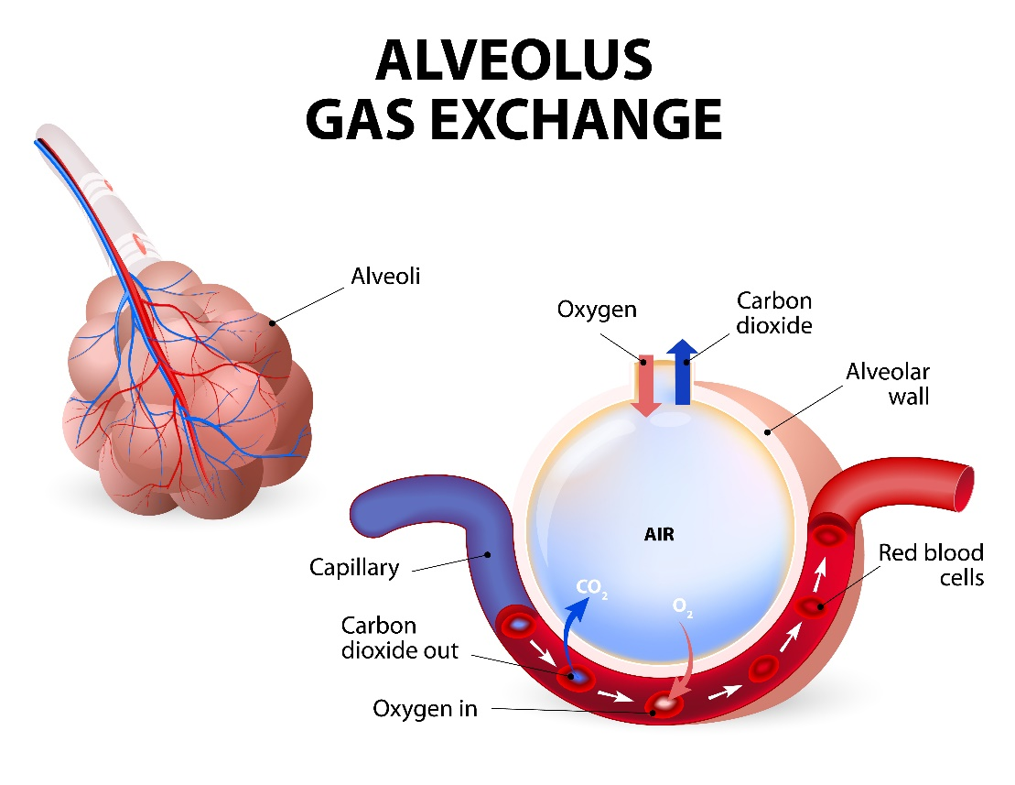

________________________________________________________________________________________________________________________________________________________________________________________________________________________________________________________________________________________________________________________________________________________________________________________________________________________________________________________________________________________________________________________________________________________________________________________________________________________________________________________________________________________________________________________________________________________________________________________________________________________________________________________________________________________________________________________________________________________________________________________________________________________________________________________________________________________________________________________________________________________________________________

1. Discus is a complex athletic skill that requires different movements.

**(6 marks)**

Describe the movements at the knee, shoulder and wrist that occur during the discus throwing action.

__________________________________________________________________________________________________________________________________________________________________________________________________________________________________________________________________________________________________________________________________________________________________________________________________________________________________________________________________________________________________________________________________________________________________________________________________________________________________________________________________________________________________________________________________________________________________________________________________________________________________________________________________________________________________________________________________________________________________________________________________________________________________

**END OF SECTION THREE**

**SPARE PAGE**

_______________________________________________________________________________________________________________________________________________________________________________________________________________________________________________________________________________________________________________________________________________________________________________________________________________________________________________________________________________________________________________________________________________________________________________________________________________________________________________________________________________________________________________________________________________________________________________________________________________________________________________________________________________________________________________________________________________________________________________________________________________________________________________________________________________________________________________________________________________________________________________________________________________________________________________________________________________________________________________________________________________________________________________________________________________________________________________________________________________________________________________________________________________________________________________________________________________________________________________________________________________________________________________________________________________________________________________________________________________________________________________________________________________________________________________________________________________________________________________________________________________________________________________________________________________________________________________________________________________________________________________________________________________________________________________________________________________________________________________________________________________________________________________________________________________________________________